電通二乙微處理器實驗 實驗結報

實驗名稱 | 四合一七段顯示器
組別 | Lab-04 | 組員 | 游竣傑

- 實驗目的
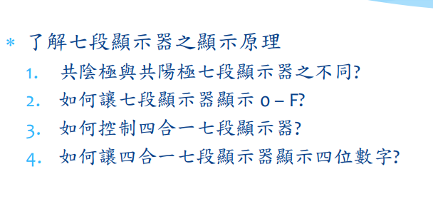
- 實驗步驟

- 程式碼
#include "SevSeg.h"
SevSeg sevseg;
byte Hour = 0;
byte Min = 0;

void setup() {
byte numDigits = 4;
byte digitPins[] = {2, 3, 4, 5};
byte segmentPins[] = {8, 9, 10, 11, 12, 13, 14, 15};
bool resistorsOnSegments = false; // 'false' means resistors are on digit pins
byte hardwareConfig = COMMON_CATHODE; // See README.md for options
bool updateWithDelays = false; // Default. Recommended
bool leadingZeros = false; // Use 'true' if you'd like to keep the leading zeros
pinMode(6,INPUT);
sevseg.begin(hardwareConfig, numDigits, digitPins, segmentPins, resistorsOnSegments, updateWithDelays, leadingZeros);
sevseg.setBrightness(90);

}

void loop() {
static unsigned long timer = millis();

boolean Pin6= digitalRead (6); // Reset
if (Pin6 == LOW)
Min = Hour = 0;

if (millis() - timer >= 100) {
timer += 100;
sevseg.setNumber(Hour * 100 + Min, 0);
Min = Min + 1;
if (Min ==60 )
{
Min = 0;
if (Hour == 23)
Hour=0;
else
Hour++;
}

}
sevseg.refreshDisplay(); // Must run repeatedly
}

- 實驗結果及分析
顯示時間，四合一七段顯示器的腳位
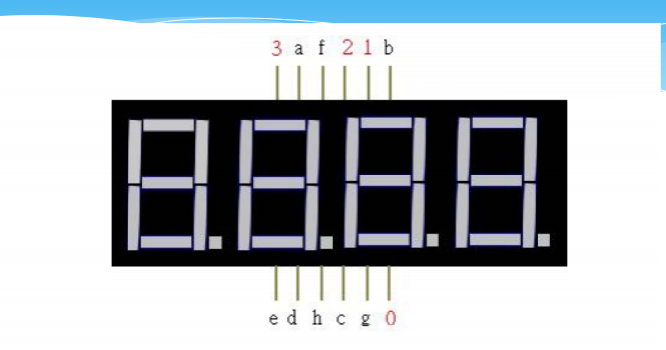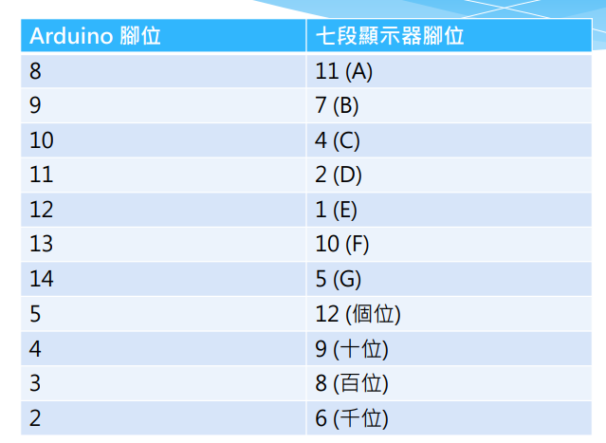
- 電路圖
